Summary for Big Mountain

Lisa Patel

The client, Big Mountain Resort, is located in Montana and offers fantastic views of the Glacier National Park and Flathead National Forest. About 350,000 ski or snowboard at this resort, so they are accommodated with 11 lifts, 2 T-bars, and 1 magic carpet. In the past, their pricing strategy was to charge a premium above the average price of resorts in its market segment. However, they have suspected the BM is not maximizing its profits, relative to the market. They want to know which facilities matters more to visitors, so that they would be willing to pay more and thus increasing profits. To do this, we needed to a create a new predictive pricing model based on the data collected from all of the ski resorts in the United States. The average price range for all the states in the dataset is shown in Figure 1.

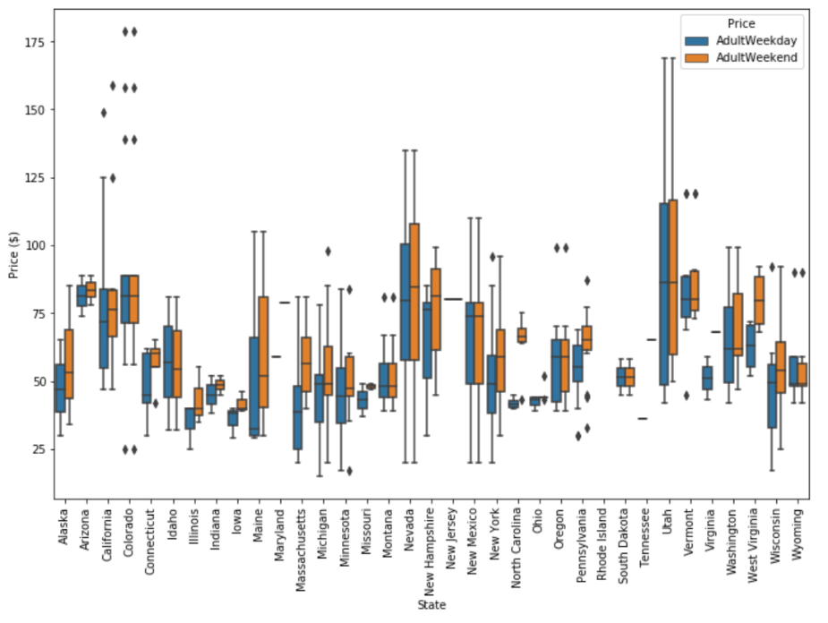After cleaning the data, there was a rough exploratory data analysis. This process produced a feature correlation heatmap, shown in Figure 2. Essentially, this shows that Adult weekend price is correlated with: fastQuads, Runs, snow Making_ac, vertical drop and total chairs. Visitors value more guaranteed snows and also prefer skiing at night if they are living in densely populated areas.

Figure : Average Ticket Prices wrt to State

For the models, we first trained linear regression model and a random forest model. Then compared which performed better by compared the R-squared, absolute mean error and squared mean error values. In the end, we chose the random forest model because it had a lower cross-validation mean absolute error by almost $1. It also had less variability and the performance on the test set was consistent with the cross-validation. This model found four dominant features that are in common with the linear model: fastQuads, Runs, Snow Making_ac, and vertical drops. The importance of the features found is shown in Figure 3.

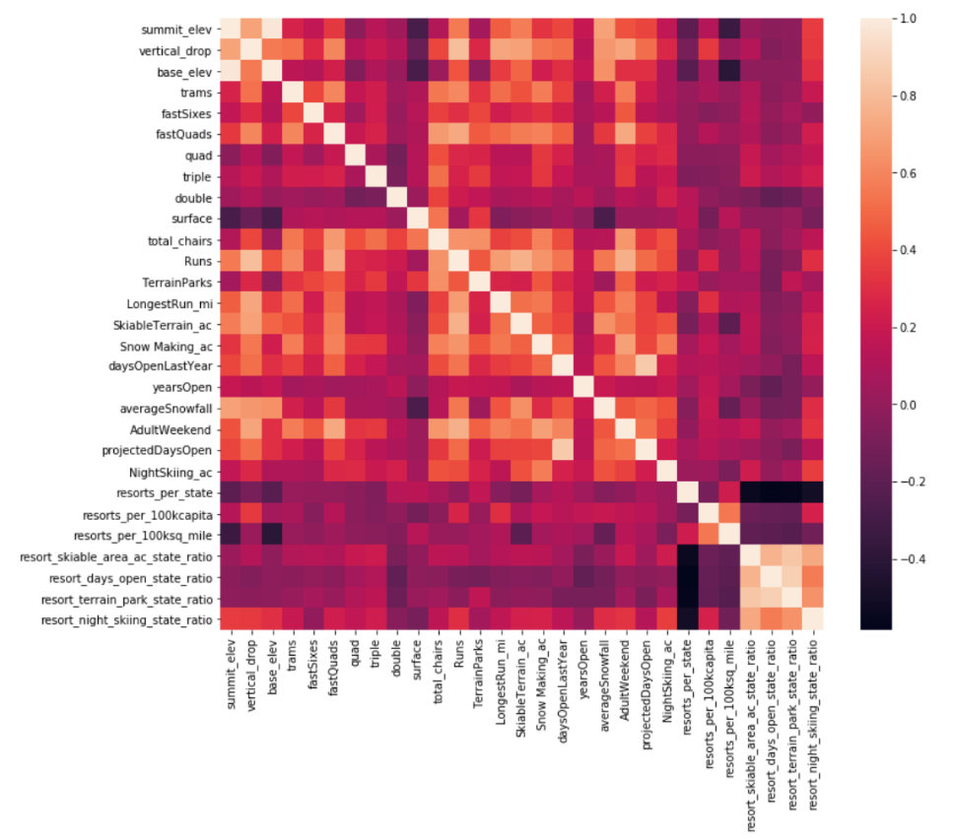There is also further evidence that shows Big Mountain can raise its ticket prices and generate more revenue. It can be seen in Figure 4, which reveals that BM is on the higher end of the distribution for the all of the dominant features found in both the linear and random forest models. So, BM was underselling.

Figure : Feature Correlation Map.

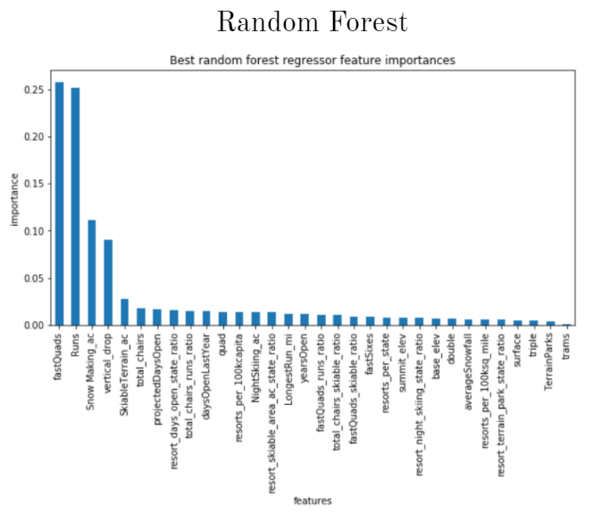So, what is the new pricing strategy and how can we improve the facilities? We ran all four scenarios shortlisted by MB through the predictive model. The best result was the scenario that involved Increasing the vertical drop by adding a run to a point 150 feet lower down but requiring the installation of an additional chair lift to bring skiers back up, without additional snow making coverage. This supports a price increase of $8.46, which was generate $14,811,594 over the year! The other scenarios do not make much of a difference in price increases or revenue.

Figure : Importance of each feature according to the Random Forest Model

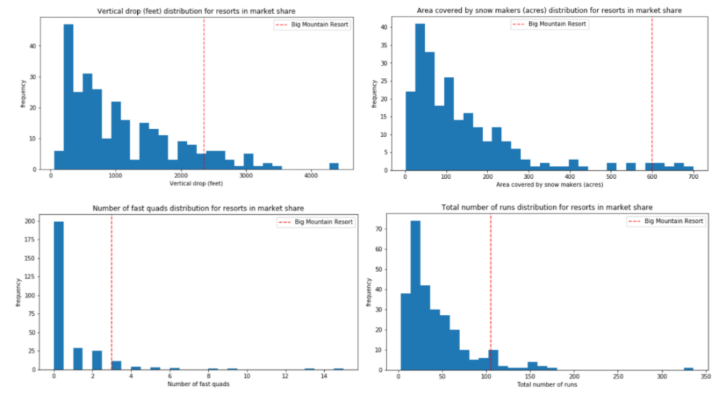

Figure : Where BM is in each feature distribution